Workshop Title
Presenters name
Affiliation/company/organization

Introduction: Briefly introduce your domain, project, or topic and explain why this workshop is relevant to the FRAM community. Describe the context or background of the topic you would like to explore together.

Workshop Focus: Describe the main topic, problem, or question your workshop will address. Specify what kind of input, discussion, or activities you would like to facilitate during the session.

Workshop Goals & Expected Outcome:
Outline the intended goal(s) of the workshop — for example, developing a shared understanding, identifying solution pathways, collecting feedback, or co-creating a concept or model.

Note: Workshops are meant to be interactive and outcome-oriented. Please indicate how you plan to structure the time (e.g., short intro + group discussion, interactive exercise, co-modelling activity, etc.).

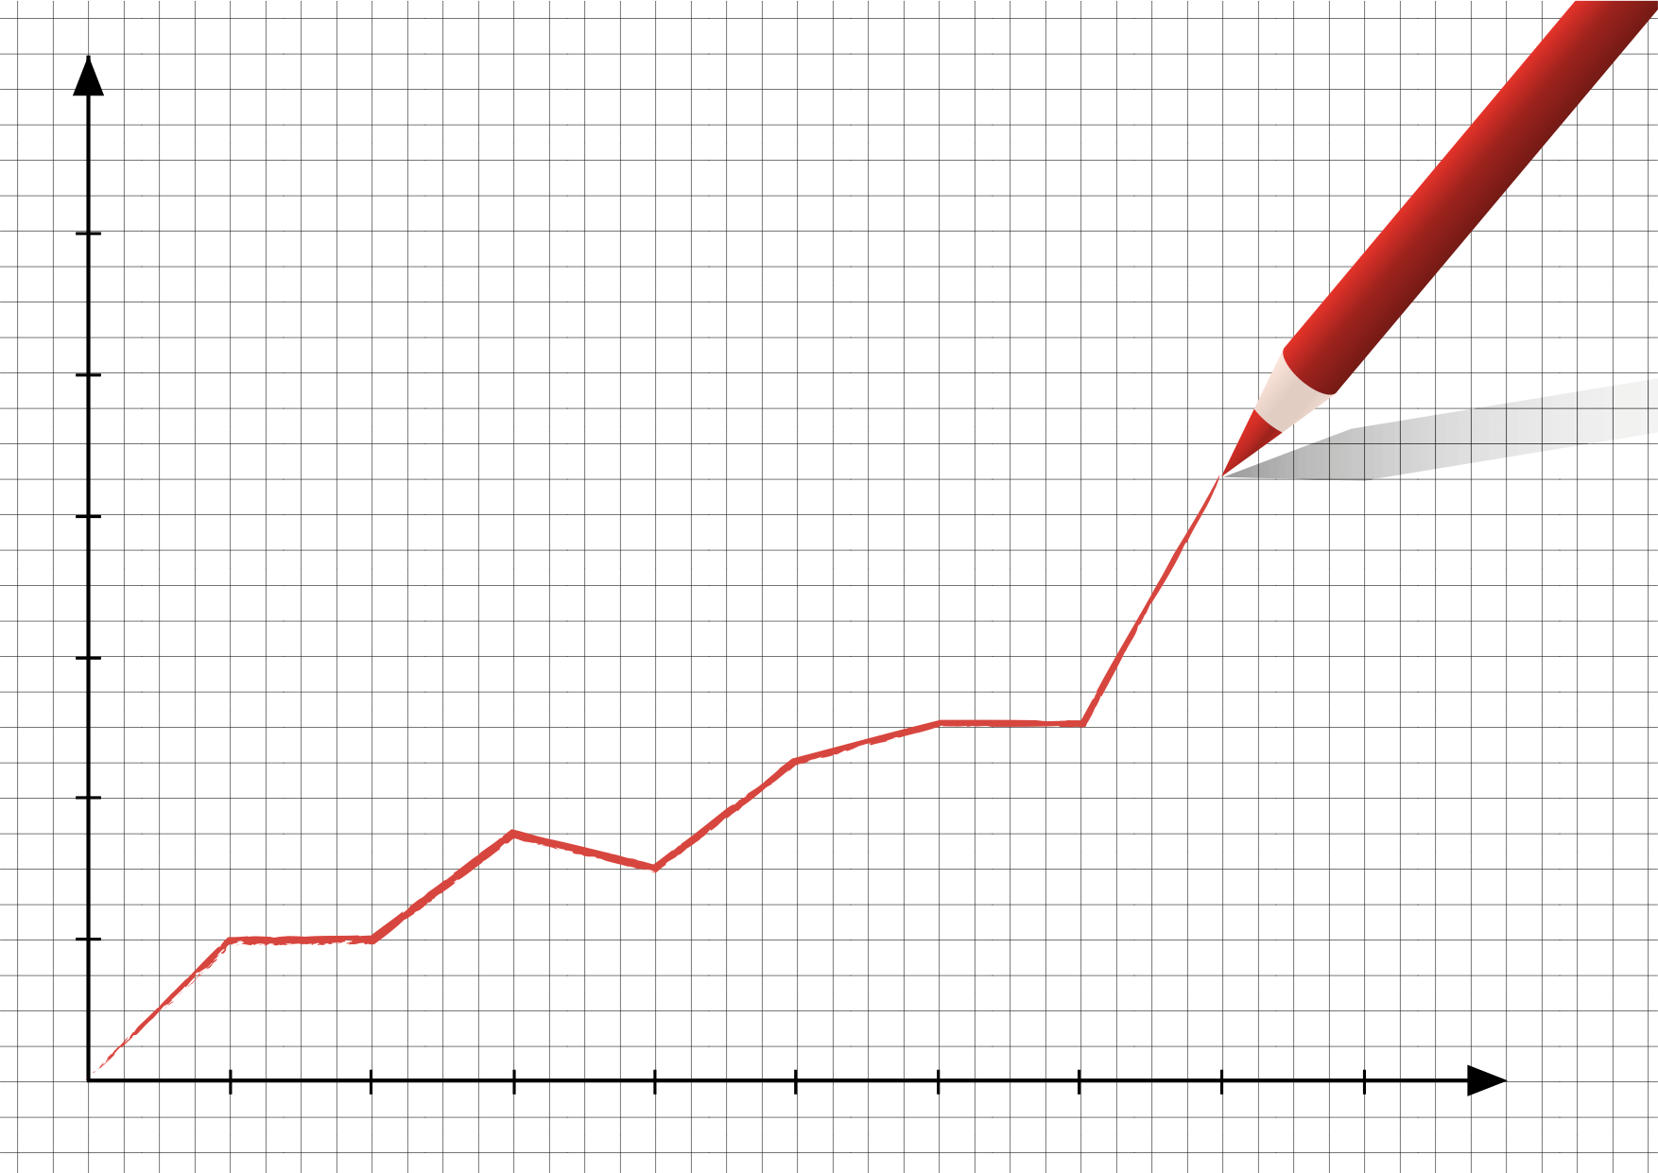
Insert Figure caption here

Supporting Figure: Supporting figures are encouraged if they make it easier to communicate your topic, help structure the discussion, or support interaction with the audience.

